Pushup Counter Device

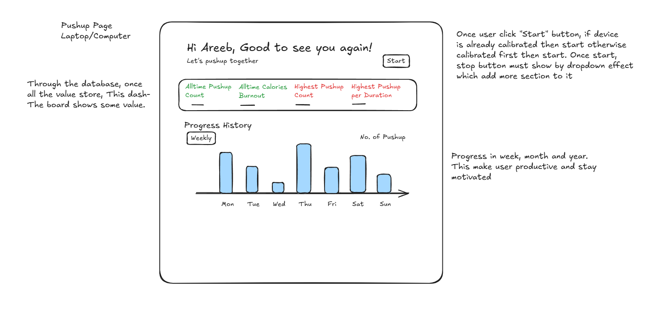
Abstract Idea:-
Most of the gym people without supportive friends gave up after the last rep of their set. Develop a device which has motivatory feedback to the gym person for doing one more reps continuously during their last rep. I am talking about reps of pushups only. Motivatory feedback based on record of users number of reps, time it took to complete and number of calories burned all in one set. Motivation feedback gave output such as “Do one more”, “This is the highest record you made - just do one more”, “Bro - you break the record”, etc on the web screen. This project is ideal for the gym person who prefers exercising alone and needs motivation.

Device Setup:-

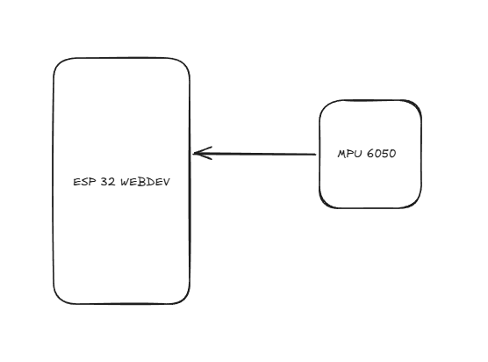

MPU 6050 would return x, y and z acceleration to ESP32 WEBDEV. In the program, we would only use z acceleration data to calculate the number of pushups.

Architecture:-
